**Update Laravel Website related to Project Management**

**Shortcuts:** Top of Doc | About the Website | Overview of Functionality | General Information  
Summary of Tasks **||** Units | Objectives | Issues | Ideas **||** User Rights | Item Categorization  
 Wiki, Forum and Chat | Wiki Features **||** Motivation and Recognition | Activity Tracking | Awards and Top Contributors | Financial Features | Globally Accessible Information | Visual Aspects | HTML Design

# Introduction

This project involves updating an existing Laravel website that has project management and other features. The website is a free non-profit platform allowing people to solve problems in society by creating issues, ideas, tasks and objectives related to the area of their interest. Wiki and Communication features such as forums, chat and private messages are present. A financial system for receiving and sending money is also present. Please see the Outline of the document in the Navigation pane on the left ← to get an idea of the various other supporting components.   
This document does not provide the full specifications of this Update task. **Some functionalities are not fully defined and will have to be decided and added while you are implementing the website.** **Any work beyond the scope of this document will be discussed, agreed by both of us and compensated for fairly and appropriately.** If you need, I will be glad to talk about the project via voice chat/screen sharing to answer questions before you bid.

# Summary of Tasks

**Your work is mentioned in this document using this blue color**. Everything else should already exist and be mostly functional (if its not, we can discuss it). Text in regular black color is provided so you can understand the existing functionality. Here’s a summary of your tasks and their projected cost:

| **#** | **Milestone Description** | **Projected Cost (US $)** |
| --- | --- | --- |
| **1** | **Resolve new Issues regularly on weekly basis (total cost for all issues)** | 500 |
| **2** | **Update** other objects as described in the document, such as Units, Objectives, Issues, Tasks and Task Management System. Update template from old to new where needed (more information) | 700 |
| **3** | **Add** Detailed User Activity Tracking | 300 |
| **4** | **Add** DonorBox implementation for Financial Transactions (and remove older methods) | 300 |
| **5** | **Update** Awards and add Top Contributors | 200 |
| **6** | QA Testing, logging issues and resolving them | 300 |
|  | **TOTAL** | **2200** |

# 

# 

# Overview of Functionality

Please see the following components of the website to understand its functionality. Once again, blue font shows work that needs to be done:

* **Units** (needs update): This is the specific focus area which people are working on e.g. Human rights, or a specific product or service. There are three subtypes of Units with minor differences explained later. A Unit can have its own Objectives, Ideas, Issues or Tasks and other features.
* **Objectives** (needs update): People can create objectives or high-level goals for the Unit.
* **Ideas:** (may need updates/fixes)People can create and discuss new Ideas relating to the Unit. They have their own **discussion** and **wiki** features like other items
* **Issues** (needs update): People can report issues (problems) related to the Unit
* **Tasks** (needs update): A Task represents some work that needs to be done. An Objective can have multiple Tasks related to it. A Task can also be created from an Issue or an Idea. There is a **Task Management System** that needs to be updated.
* All of these objects (except for the Unit object) have their own **discussion** threads where people can discuss the Objective, Idea, Issue or Task.
* All these objects are **wiki** objects which means multiple people can edit and improve them. An edit history will be available for each object.

**Other components:**

* **Wiki**: A separate wiki for each Unit is needed (this is in addition to most objects being of a wiki nature as mentioned above). A wiki is a collection of pages or objects that can be edited by anyone.
* **Forum**: A separate Forum for each Unit is needed (this is in addition to most objects having their discussion threads).
* **Chat**: Every Unit should have Text Chat functionality that saves all messages sent in the past.
* **User Activity Tracking** (needs update): We need to track various activities done by users on the site so they can be rewarded and recognized for the activities.
* **User Recognition** (needs update): This includes top contributors and awards
* **Financial Donations and distribution**(needs update): Anyone should be able to donate to a Unit, Objective, Issue, Idea or a User. A user should be able to withdraw funds they have received. Need to integrate DonoxBox
* An **HTML template** is used for the website (new template already exists; linked here; most page views have been converted over; some page views need the update)

As you can guess once the website functionality for a Unit has been developed, it can be used for all Units.

# Concepts and Background

## Examples of other sites

To help you understand the website, I will first give some examples of websites where people come together to do tasks. Wikipedia is one example where editors from all over the world join efforts to work together on information about topics. Reddit.com is a website based entirely on what the community decides. Freelancer is a website where people post tasks and others complete them for money. Facebook.com is a website where people come together for online sharing. There are many examples in today’s world where people from all over the world join a website and do various things together.

## Purpose of the Javul website

The name of the website is Javul. This word is from the Hungarian language and it means ‘to improve’. The purpose of the Javul website is to help people from all over the world work together on problems and issues facing society. The Javul website is basically a generic problem-solving and task management system that can be used for any situation. Many Task management systems already exist but none of them have all the features we need.  
The goal of the Javul website is to link together these three things: (1) Smart people with good ideas. (2) Hard working people willing to work and implement those ideas (3) Any available rewards/compensation or money rewarded for good ideas or hard work.

## Example of a Unit

As an example, “Women’s Rights in Afghanistan”is a **Unit** (a group)that can be created by anyone. People can create **Objectives** (or goals) that belong to this. Each Objective can have different **Tasks** that need to be completed. When all the tasks of that objective are completed, the Objective can be marked as “complete”. Various **Issues** and **Ideas** can be discussed and tasks can be created from these objects too. People can therefore work to improve women’s rights in Afghanistan like they would in a typical Project Management System. We can't use a typical project management system because none of them provide all the functionality we need.

Later the Javul website will also have its own unit, where the purpose will be to improve the Javul website and the tools it provides to all other units on the website. Here is a basic diagram showing the relationship between Units, Objectives and Tasks, Issues and Ideas:



Some objects will have additional related objects for example an Issue can link to other related Issues. These details are discussed below.

At this point if you like, you can quickly scroll down to see the HTML Design to get a basic visual idea of the main web pages and then continue reading from here.

# General Information

## About this document

* Please read this document thoroughly before starting work and if possible, before bidding. You can use the section Outline on the left to understand the document better.
* Nothing in this document is fixed. If you have suggestions for improving the functionality of the website let me know.
* Feel free to make a copy of this document for yourself in any format and make small edits if that helps you navigate the document better. You can also click **‘View → Show Print Layout’** to toggle the view to show a continuous document without whitespace for headers and footers.
* There may be some errors or things that are not clear. If you see anything please let me know and we can make corrections and get more clarification.

## Existing Code / Previous version of website

An initial version of the website at <http://javul.org/> was developed a few years ago and recently updated to Laravel version 10. This new effort is adding or updating features. Gitlab code for the initial version is available at: <https://github.com/javulorg/javul>. Of course you can use any open-source code you can find anywhere or anything else you can legally use. An HTML/CSS template is available for use (see screenshot here). Github is where the code will be maintained.

## Skills Needed

This project requires expert skill levels and past experience for Laravel, PHP, SQL/Databases, HTML, CSS, Javascript, Programming and other areas. You will need to be creative, have good problem-solving skills and be able to pay attention to detail. A good command of the English language is also required.

## Qualifications for Bidding

Significant experience developing complex websites with custom coding is required. If you have very little website development experience and very little feedback, kindly do not bid. Thank you.  
To increase the chances of your bid being considered: (1) Read this document carefully and understand the requirements of the website. (2) Mention your past experience with Laravel and previous examples of similar work. (3) Send me a PM and we can discuss your qualifications for the project.

## About Me

I have prior experience with web design (HTML, CSS, Javascript, PHP), computer programming (C/C++), graphic design (Photoshop) and databases. I’m therefore familiar with these topics and able to discuss them with you to some extent in order to find solutions/suggestions if needed. This project is beyond the scope of my skills and time and it's complex so I need your experienced help. You’ll be doing the majority of the development but I may also want to get involved in the development of the website so I may need your help for a few things. If you have suggestions on how to do something in a better way, please let me know.

In the past projects that people have worked on for me I have often provided extra compensation depending on the effort involved for additional work not mentioned here. I have good feedback and have always had a good relationship with the people I work with. I am doing this project with hopes that it will benefit society. It will always be free for people to use.

## Time Taken

Completion time is estimated to be 3 to 5 months.

## Release of Rights

The project’s code will be open-source so please keep that in mind that your coding may be seen, used and modified by other people (general public) in the future. You agree to release all the rights to the work you will do for this project. If you utilize third parties to do some of the project work, please make sure it is open-source.

## Quality of programming and Server Setup

Please follow good programming practices. Use well designed functions as much as possible instead of duplicating code. Use good variable names and use comments to explain the code as much as possible so anyone can work on it later.

## Template-based Coding

Many pages will have a common structure (header, menu links, footer etc). It should be easy to update the template so it's updated for all pages.

## Screen Resolution

The website should have full functionality on screens of 1200 pixels wide for Desktop and below that apply a responsive design that collapses sections into menus so the layout works on mobile screens of a minimum 350 pixels wide. The HTML/CSS design that has been provided has the responsive feature built into it already.

## Unified Logins

Once a user account has been created, it can be used on the whole website and all its features.

## QA Testing and Debugging

The website will need to be tested thoroughly during development and in the end to make sure all required functionality is worked correctly with issues documented and resolved on Github.

## Final Delivery

The final delivery will include all the code, a working website on its actual domain (javul.org) and the creation of the first Unit (Javul.org). As is the case for a Unit, it will have its own forum, wiki and text chat. An About page will have been created on the wiki.

# Units

The Unit Home page will show the following things:

* What objectives, tasks, issues and ideas are associated with that unit.
* Recent activity on all these objects
* Any funds associated with that Unit (available amount and awarded amount)
* ‘About’ text (uses the same wiki feature developed for other objects)
* Related Units. A user can specify if a Unit is related to other Units.

**Database Attributes for Unit** (edit as needed):

* Unique ID (number)
* Name of Unit (128 char)
* Unit Type: (3 types) Product, Service or ‘People’s Government’ (store internally as integers 0,1,2 and show the text depending on the language code for the Unit)
* Applicable if Type is Product or Service:
  + Product Name (only applicable if type is a Product) (128 char)
  + Service Name (only applicable if type is a Service) (128 char)
  + Business Model: Community-owned, or Corporate [internally 0,1]
  + Operational Grade (described above: 5 chars max only editable by the site admin). Only displayed if Business Model is ‘Corporate’. [internally a decimal number]
  + Company (128 char)
* Only applicable if Unit Type is ‘People’s Government’:
  + Scope: Possible values are City, County, State, National, International (internally 0,1,2,3,4)
* Issue Resolution Rate (floating point up to 1 decimal e.g. 96.4; described later in the Issues section)
* Location (see section below for detail)
* ‘About’ text (will be part of the wiki, described later)
* Unit Category (what kind of unit is this? See section below for detail)
* Objective IDs (Objectives associated with this Unit)
* Language: Language code. For possible values, use the two letter codes for 639-1 on [wikipedia](https://en.wikipedia.org/wiki/List_of_ISO_639-1_codes). For example for English it will be en and displayed as English
* Task ID’s (Tasks associated with this Unit)
* Issue ID’s (Issues associated with this Unit)
* Idea ID’s (Ideas associated with this Unit)
* State: Active, Archived (changed by site admin) [internally 0,1]. Display this field only if Archived
* Funded: This is a percentage. (e.g. 104% Funded = Funds Available / Funds Needed x 100). The calculation of this number is described in the Financial Features section.
* Related Units (other Unit IDs)
* Parent/Child Units:
  + Parent’s Unit ID (if this Unit is a Child unit of another Unit)
  + Child Unit IDs (all Unit IDs for child units)

**Aspects of any page belonging to a Unit:**

All pages belonging to a Unit will have Unit related links and information as shown in the template. A Unit has many sub-pages beneath it:

* Its home page
* Any page of an Objective for that Unit
* Any page for a Task, Issue or Idea in that unit
* Any forum page, for that Unit’s forum
* Any Wiki page, for that Unit’s wiki
* Other pages as determined in this document

## Unit Category

When a Unit is created, a category has to be attached to it so people know what kind of Unit it is. The category is a tree-structure with sub-categories on multiple levels e.g:

Urban Planning -> Public Transport -> Taxis

When a user edits a Unit, they are shown the category section and next to it is a link “Suggest a Category edit”. This link takes them to a form that has the Unit ID and a comment box. This submission then creates a new discussion thread in a ‘Unit Categories’ forum within the Javul.org Unit. The Site Admin can then review the request and make the requested changes to the Category database using an Editing interface for ‘Add/Edit Unit Category’.

The following is a suggestion for the database details of a Unit category item but let me know if you have ideas for a better implementation:

* Category ID (unique)
* Text (used to display the category on the website)
* Parent Category and Child categories

# Objectives

An Objective is a high-level goal within a Unit. The home page of an Objective is meant to give important information about it. It tells the following things:

* What tasks are associated with that objective
* Recent activity on those tasks
* Parent and child objectives.
* Any funds associated with that Objective (available amount and awarded amount)
* Quick overview of the Unit for that Objective (unit name, type of unit, total funds available in the unit)

**Parents/Child objectives**

When an objective is created or edited, people can specify that another objective is its parent or child. There can be multiple child objectives but only one parent objective. People can search for objectives by keywords. By default, they can search by objectives belonging to the same Unit or the objective can belong to any unit on the site. For that they can browse to their Unit and find the objective they are looking for. Almost all attributes of an Objective can be edited by anyone.

**Database Attributes** (edit as needed). **Bold items** are those shown in an Objective detail view.:

* Unique ID (system generated)
* **Title of Objective** (180 char; Wiki editing; required)
* **Text Description** (any length; Wiki editing; required)
* **Priority** (averaged decimal value with starting value of 3; any user can rate it from 1 to 5). See Priority Calculation below.
* Unit ID (Objective belongs to this Unit)
* Task ID’s (**Tasks linked to this Objective**)
* Issues ID’s (**Issues linked to this Objective**)
* Idea IDs (**Ideas linked to this Objective**)
* **Status:** In progress. Completed, Archived
* **Funds available, funds awarded** (updated when anyone donates to this Objective or when funds are distributed from it)
* **Parent/Child Objectives**:
  + Parent’s Objective ID (is this Objective a Child objective of a Parent objective?)
  + Child Objectives (list all objectives for which this Objective is a parent)
* **User Comments Thread**

Visual Layout: The Visual layout of an Objective can be adopted from the Unit Home page’s layout. The left side of the website will remain the same. The center/core part will show the elements described below in the Wireframe Section

## Priority Calculation

Priority Calculation is similar to product reviews that are rated from 1 to 5, with a graphic and also numerical representation (e.g. 4.3 out of 5 and then a visual graphic showing that ratio). When a user creates an object such as Objective, Issue or Idea they can set an initial rating from 1 to 5. Any other user can also set a rating and the values are averaged. A user can change their rating and that would effect the calculation. This may mean we have to keep track of each vote and recalculate it when its changed. The internet may have some existing solutions or suggestions on how to do this.

# Issues

An Issue object can be used by people to report problems relating to the Unit. Almost all attributes of an Objective can be edited by anyone. Attributes include:

* Unique ID
* Issue Title (180 chars; wiki editing; required)
* Issue description (text field of any length; wiki editing; required)
* Resolution (text field of any length)
* Funds available, funds awarded (updated when anyone donates to this Issue or when funds are distributed from it)
* Issue Type (taken from Type Table discussed later)
* File attachments
* Status. Possible values: Unverified (Open), Verified (Open), Assigned to Task, Resolved
* Priority (averaged decimal value with starting value of 3; any user can rate it from 1 to 5)
* Related Objects:
  + Unit ID (Issue belongs to which Unit?)
  + Task IDs (Tasks related to this Issue)
  + Issue ID (other Issues related to this Issue, including Parent or Child-Issues; see below)
  + Objective ID (Objectives related to this Issue).
* User Comments Thread (confirm this exists)

Usually the unit ID is selected automatically when possible. The Issue description and other attributes are filled out by the user and can be edited later by other users. By clicking on “Create a Task for this Issue” (visible when an Issue has been created), the user is taken to the Task creation page and a link is created between the Issue and Task. An issue is considered as ‘Verified’ when three people have marked it as verified, or if the site admin has marked it as verified.

**Linking to Parent or Child-Issue:** When a user clicks on the link ‘Link to Parent or Child-Issue’, they are shown a form where they can select another issue (this can be within that same Unit, or site-side), and they can select whether that Issue is a Parent or Child Issue.

**Issue Resolution Rate:** This number is available for every Unit and is shown on the side bar of each Unit’s page:

Total Resolved Issues / Total number of Verified Issues x100

This means we keep track of the total Resolved Issues and Total number of Verified Issues. For Statistics, we want to keep a total number for all of history, and also for the last 6 months.

# Ideas

This may need updates or fixes. Ideas are created by users who have a new idea for the Unit. Attributes include:

* Unique ID
* Idea Title (180 chars; wiki editing; required)
* Idea description (text field of any length; wiki editing; required)
* Idea Type (taken from Type Table discussed later)
* Funds available, funds awarded (updated when anyone donates to this Idea or when funds are distributed from it)
* File attachments
* Status. Values: Draft, Assigned to Task, Implemented
* Priority (averaged decimal value with starting value of 3; any user can rate it from 1 to 5)
* Related Objects:
  + Unit ID (Issue belongs to which Unit?)
  + Task ID (Task related to this Idea)
  + Issue ID (other Issue related to this Idea)
* User Comments Thread

# Task Management

**Task Management needs to be updated. See below.** Completing Tasks on the website resolves Objectives, Ideas and Issues and so thats where all the work is done. The Task Management functionality will be more complicated than other areas of the website. Here’s the short summary of how the task system works. It's a simple process that most people are familiar with. A team of people work on creating and editing a task. After task editing is complete, people who are interested in completing the task can bid on it. After the bidding stage, the task is awarded to the chosen bidder and the work is completed by the bidder. The work is then evaluated for quality of work and the task reward (if any) is awarded.

Details of the task system are mentioned below.

**Task Information**

A task can have certain attributes. The goal is to have a task defined well so all the important information is present. Here is a list of attributes for tasks. Required fields that must be filled out by the task creator are in **Bold** (there are only a few).

1. Basic Task Information
   1. **Name of Task** (shown in website hyperlinks)
   2. Summary (optional)
   3. **Description** (longer text giving detail)
2. Task Skills: (to make it easy for people searching for tasks that require those skills). This data is derived from the same database (it will be described later as ‘Skills’) that task workers use to list their skills. A task can have multiple skills associated with it.
3. Action Items (what needs to be done, presented in a quantifiable way). In bullet form. These items will also be tracked during task completion.
4. Estimated Completion Time (hours, days, weeks or months)
5. Reward or compensation: Monetary or points.
6. Other attributes:
   1. Task ID: Every task has a unique task ID in the system.
   2. Unit ID: Task belongs to which unit?
   3. Objective ID Task belongs to which objective? [optional ………… ]
   4. Issue ID (explained below in Issue Reporting section; there can be multiple Issue ID’s for same task)
   5. **Idea ID**
   6. Task Status Task status. Explained in a section below.
   7. User ID of Task creator: Person who created the task
   8. File Attachments (safe file types only such as doc, docx, pdf, txt, jpg, png, ppt, pptx, etc)

**Details on the above fields for task information structure:**

Name: Short (200 characters). This field is used when a task is linked from Units or Objectives or other places. In other words, the text of the link will be the task Name.

Summary (optional): 1000 characters

Description (longer text giving detail). 10k characters

Task Skills: These are hyper-linked categories, derived from the Skills table. For example, a person can create a task about “working in a hair salon” and the skills required may be: Haircutting, Customer service, Chemical Hair treatment.

That is how the skills will be listed for that task, as 3 separate skills. The Skills database is talked about in detail later.

Action Items (optional)

Action items are items in list form. They break the task down into smaller pieces so the Task Worker knows what key points need to be worked on for the task to be completed. Action items help clarify the task further and make it easier for the Task Worker to see the main points of the task or get an overview of the task.

A Task editor just needs options to add,delete or edit an Action item.

When submitting a completed task, the task worker makes a checkmark next to each item so it shows they have completed that action item.

Estimated Completion Time. Hours to months (Task Creator selects a double digit number and also the unit of time for hours, days, weeks or months). Data should be saved in the database in a format that makes it possible to sort tasks by length of time so for example only storing number of equivalent hours or some other recommended method for databases.

Reward or compensation: Monetary or points. Task creator can set the numerical amount and also select one of two choices (dropdowns) for the unit, which is: $ or just ‘points’.

**Secondary attributes**

Internal attributes (not shown to user but used by the software):

Task ID: A unique number for each task (auto-increment)

Unit ID: Task belongs to which unit?

Objective ID: Task belongs to which objective?

Issue ID: A task can be linked to multiple issues. Issue reporting is explained later in a section.

Idea ID: Related Idea

User ID of Task creator: This is the User ID of person who created the task. The task item will show the user’s name and link to their profile (using their user ID). In a separate field, you can also store the username if you like (it will reduce database queries).

Task Status: Explained in a section below.

Attachments: The task editors can attach files (as many as needed. Or allow for 10). Like in most other interfaces, there will just be one “Add attachment” link and people can add additional attachments. File types should be all safe types, such as: doc, docx, pdf, jpg, bmp, png, xls, xlsx, etc.

*Next page*

**Task Status**

Tasks can be in any of these states. **These states need to be updated**:

| **#** | **Task State** | **Description** |
| --- | --- | --- |
| **1** | **Draft** | Anyone can edit the task and improve it and change status to the next state (2) |
| **2** | **Waiting for Approval** | Task cannot be edited anymore. It is now waiting to be approved for bidding. Status change to the next state (3) is done by Site Admin and users with 'Task Management' right |
| **3** | **Open for Bidding** | People can bid on the task now. When there's 1 bid on it, a timer of 10 days starts, after which the system updates the status to the next state |
| **4** | **Bid Selection** | Site Admin and users with the ‘Task Management’ right are now reviewing the bids and they select the winning bidder. |
| **5** | **Assigned** | Now the bidder has to accept the task; If not accepted, Task management can change the assignment, cancel or archive the task. |
| **6** | **In Progress** | Work in progress by the person to whom the task was assigned. |
| **7** | **'Completed (Under Evaluation)'** | User submits the completed task for evaluation. |
| **8** | **'Completed'** | This status is set by the Site Admin or Task management users. Funds of the Task are released to the user. |
| 9 | **Archived** | Task was canceled at some point e.g. it was later seen that it was not a valid or viable task or it was abandoned for some reason. |

Anyone on the site can browse to a Unit’s Objectives and create a task for that Unit.

When a task is created, it will be in the ‘Editable’ state.

The Unit Admin, Task Management and Site Admin can change the state of a task in any way. As mentioned before, all actions on the site are logged so this action is also logged.

**Further Detail on Task management:**

This section explains in more detail what happens during the task management process from start to finish.

* **Task Creation:** A user goes to a Unit, Objective, Idea or Issue and clicks “Create Task”. They are shown the task creation page where they can fill out all the fields for a task. Some fields are pre-filled depending on the link they clicked to create the task. They click the Submit button and task is created. The system automatically assigns it to the Unit, Objective, Issue or Idea for which the task was created.  
  Forum thread created: At the time a task is created, its forum entry for discussion is also created automatically. This is a thread dedicated to any discussion about that task. That forum discussion is displayed under the task description. This discussion is also available in the ‘Tasks’ section of the forum. The Forum section of the website is discussed separately in this document.
* **Task Editing:** Next people start editing the task and they can also leave comments in the forum thread. All edits to the Task are logged in the task history. This is similar to what happens in a wiki. These items are recorded: User who made the edit, time of edit, edit summary, links to old and new version of the task.  
  When people are working on a task, the task status is displayed like this:  
  “Task Status: Draft”  
  When a task is in Draft status, there is also a link called ‘Submit for Approval’. When clicked, its status changes to status #2 (Waiting for approval).
* **Approval:** Site Admin, Unit Admin or users with ‘Task Management’ rights will now review the task and click on a link called ‘Approve for Bidding’. Its status will change to ‘Open for Bidding’.
* **Task Bidding:** The task has been approved and is now open for bidding. People who are interested in completing a task can ‘bid’ in such tasks. They can enter a comment, enter the amount of points or money they want for completing the task. “Bid now” is the link which submits their bid.  
  Tasks are bid for 10 days. Tasks that receive no bids, stay open for bidding. When the first bid is received, a timer for 10 days starts. At the end of the 10 days, the task status changes to “Bid Selection”.
* **Bid Selection:** The task is now waiting for Site/Unit Admin or Task Management users to assign the task to one of the bidders. When the task is assigned the task status becomes …
* **Assigned:** The user who got the task awarded, is asked to confirm that they accept the task. They have a “My Tasks” link which shows them information about the tasks they are involved in (for creating, editing, bidding, work in progress, completed etc).   
  ‘Assigned‘ shows them the tasks they have been assigned. When a task has been assigned, they are shown a prompt that asks them if they accept the assignment. If they do, the status is changed to:
* **In Progress:** The task worker starts working on the task. After they are done, they can attach files and write a comment explaining the task completion and change the status to:
* **'Completed (Under Evaluation)':** Now the Site Admin, Unit Admin or Task Management users can evaluate the task and rate the task worker on the quality of work done and the timeliness and release any funds reserved for the task. If they think the task is complete, they can change the status to ‘Completed’.   
  If they think it needs more work, they can change the status back to “assigned” for the same user. They will need to add a comment for why they made that status change.
* **Complete:** The task is completed.
* **Canceled**: The option to change a task from state X to “Canceled” is available in the following situation. Task Worker to whom task was assigned, has the task “in progress” but can change the status to “canceled”. They will be asked to confirm the cancellation and will need to give a reason for this status change.

# User Rights

Users have various rights on the site:

* Site Admin (only the site owner has this right)
* These three rights are given to a user by the Site Admin:
  + Unit Admin
  + Task Management
  + Moderator

# Item Categories/Specializations

At the bottom of the site there’s a link called ‘Site Maintenance’. It will go to the ‘Unit’ for Javul.org.

## Skills

Similar to the above, Skills also have a tree-like structure so it's easier to browse them. They are used in various places on the site:

* Task description (as described above in the Tasks section): A task can have several skills associated with it. This means the person completing that task needs to have those skills.
* User profile (someone listing their skills on the website)

The Skills database will also be user editable with a request form that creates a forum thread in the Skills forum.

## Areas of Interest

‘Areas of Interest’ is a field that a user can use to tell people what areas they are interested in. These will appear on their user profiles. Like Skills, they can be created, edited and managed in a tree-like structure. A user can edit their ‘areas of interest’ by accessing this tree structure and adding any number of nodes from it. These nodes are then displayed on the user’s profile.

## Location Database

The Location database can be used for Units and for Users. Units can have a geographic location assigned to them. Users can also specify their own geographic locations that appear in their profile.  
We want to design the Location interface so it's easy to find the location they are looking for. For example they could first be shown the list of countries. After they select a country, they can start narrowing down to state/ region/cities etc. You can start with all the countries in the world and their major cities. You can use any existing license-free/open source country and city database that you can find on the internet. One location called “Global” is available at the top of the list and then a list separator. We also want to show the top 10 most often used locations at the top and then the complete list of locations appears (for example United States, UK, Canada, Countries in Europe etc). The location database will also be tree based for example: World Region X ([examples](https://en.wikipedia.org/wiki/United_Nations_geoscheme)) → Country Y → City Z

# Wiki, Forum and Chat

All Units have their own website features (forum, chat and wiki) so users working on those units can collaborate together. The links to these features are present on the Unit’s home page as can be seen in the Wireframes. On any page belonging to a Unit whether it's a task, objective, idea, issue, forum post, wiki page or chat, the unit presence (for example name of Unit and unit type) will be visible. This will tell the visitor they are on a page belonging to that unit.  
Please investigate what open-source software can be used for these features. Use the best available free software and integrate it into the website.

## Forum / Discussion Threads

Try to use existing open-source software for this and other tools to make it easy or use/modify the existing source code. Every Unit must have its own forum. This forum is created automatically at the time of the Unit creation. All forums must have these four headers: General Discussion, Objectives, Tasks, Issues, Ideas. Forum threads are automatically created when a Task, Objective, Issue or Idea is created. Note that once the functionality for a Discussion thread is created, it can be used for all other objects that need it.

Forum posts should work like they do on reddit.com: Allow sorting by time (new, oldest posts) and also ranking. Like on reddit.com, each comment on the website should have an upvote/downvote button.

## Text chat

Each Unit needs its own text chat feature.Again try to find an existing open-source solution or use/modify the existing code.

## 

# Wiki Features

## Unit Wiki

Every Unit will have its own Wiki. A wiki is a collection of pages that can be edited by anyone on the website. We need page editing, page linking, image embedding, page history and other functionality. You can either use the previously developed code for the wiki functionality or use any open-source wiki software. It would be best to use something relatively simple and where it's easy to create a wiki for each created Unit.

Requirements:

* Each page should have a Unit ID for the unit it belongs to. This will help in organization and searching and keeping wiki pages grouped together for the same Unit
* A wiki page must be embedded in the rest of the website
* When the main link of a wiki is clicked, the website template changes to show we’re visiting the wiki section of the unit
* Wiki must be PHP based because the rest of the website will also be PHP based
* Need Page history for each page, with rich HTML features like text formatting, tables, insertion of images

## Wiki features for other Objects

As described before, edits to most objects on the site such as units, objectives, tasks, issues and ideas should be saved so we can see what the previous version of the item was, date of the revision and user who made the change. Note that this is in addition to the Wiki described above that is provided for a Unit.

## Databases for Wiki and Forum

It may be best to have one database for the wiki for the whole website and have separate columns for Unit ID and similarly for the Wiki.

# Motivation and Recognition

We have to keep track of who the best contributors are and reward them for their work. Most activities on the site therefore need to be tracked for each user.

## User Activity Tracking

This data is shown on a user’s profile. The goal of this activity monitoring is to identify our top contributors and potential leaders, people who give good ideas or work hard to complete tasks in the best way possible. Anyone with a good history of contributions could be a good candidate for leading our societies in various capacities including government or related to a product/service. Here are the items we want to show on their profile:

* **Most active Units** (determined by how many Activity points a user has for each unit they’ve performed any activity in)
* **Tasks:**
  + Tasks **Created**, Tasks **Edited**, Tasks **Completed**
  + Provided for **Task completion**. The 2 categories of feedback are: **Quality of work**, **Timeliness**. This is displayed in the user’s profile page, and when they are placing a bid.
* **Objectives**:
  + Objectives **Created**, Objectives **Edited** (Total Number)
  + Objectives **Creation Upvote Ratio**. E.g. if they created 5 Objectives and received 150 upvotes on them, the Upvote ratio is = 30 (150 upvotes /5 objectives)
  + Objectives **Edits Upvote Ratio**. Similar to above but for edits
* The above statistics repeated for **Issues** and **Ideas**
* **Total Activity Points**: This is the sum of all actions performed by a user e.g. if they had 10 edits and 2 task creations, that's 12 points.
* Above Statistics for **last 6 months** and also **Lifetime.** For the last 6 months statistics we can discuss how to implement the programming logic so that data can be kept up to date.
* Total Number of **Upvotes given** for all objects
* Comments:
  + Total number of **Comments** added
  + Total number of **upvotes received**
  + **Comments/Upvotes Received Ratio** (2 decimal places e.g. 1.07)
  + Links for **Recent** (Most recent Comments), **Top** (sorted by Upvotes received)
* **Activity by Unit:** Track all activities for the different **Units** that the user performs the activity in
* Show most active Units at top (show rank)
* This means each activity needs to be tracked for the **Unit** and **date** it was performed.
* **Awards** won (see below)

## Other Information shown on a User’s profile

In addition to the above, the following information is also shown on a user’s profile:

* Username
* Account age (creation date)
* Geographic location (optional)
* Areas of Interest (user can edit these)
* Skills (user can edit these)

## Unit Statistics

These statistics are shown on a Unit’s ‘Statistics’ page

* Top Issues, Objectives, Ideas and Tasks (highest upvotes received)
* Users with most activity points
* Users with highest total upvotes received issues, tasks, ideas (3 separate statistics)
* Above with links for All time, Last 6 months (default view), last 30 days

## Global Site Statistics

This information is shown at the bottom of all pages on the site.

* Units Created
* Total Objectives, Issues, Ideas and Tasks created and also edited
* Objectives Completed, Tasks completed, Issues Resolved
* Number of Users (Top Contributors)
* Total Forum Threads
* Total Comments
* Total wiki edits
* Total funds awarded
* Total funds available

# Activity Tracking and Watchlists

## Logging of Site Activity

All activity is logged and recorded on the site according to the type of activity. For example:

* User X created/edited/deleted a unit/objective/task Y.
* User X replied to discussion Y.
* User X changed the status of task Y to Z (Z is from task_status in Tasks table)
* User X evaluated Task Y for Objective Z, in Unit ZZ.

We want as many hyperlinks as possible. Links are underlined in the example. For example User X can be linked to that user's profile. Task Y will link to the page for that task. "Replied to" will link to the individual reply while "discussion Y" will link to the thread in which that reply is located.

Database queries of various kinds should be possible:

* Display all actions of a certain user (on their user profile)
* Display all actions of a certain kind
* All actions done on a certain object (object can be a task, objective or unit)

Logs are sortable by date or other fields.

## Watchlists

A user should be able to add various items to their watch lists such as Units, Objectives, Tasks, Issues and Ideas. Each of these items will have a ‘favorite’ button (heart icon) which will add the item to their watch list. When they click on the link “Watchlist”, they can see the recent activity on that object (comments, edits etc).

# Awards and Top Contributors

## Awards

This functionality needs to be updated. Allow people to nominate others for awards (every 6 months). The award nomination period will run for two weeks in January and July. Anyone can nominate a User for an award via their user profile or via the awards page. An award is specific to a Unit or it can be a site-wide award. The nominator provides a statement (comment). Other people can upvote the nomination and also add comments. Awards are displayed on a user’s profile page. Award types include:

* **Leadership**: Showing general leadership in taking initiatives and dealing with difficult situations
* **Innovation**: Vote for people who show a strong ability to be creative and think outside the box.
* **Mediator/Facilitator**: People who help resolve conflicts by helping others compromise or help others work together better.
* **Meta Activities**
* **Research and Gathering Data**
* **International Collaboration**
* **Accountability**: People who do high-quality accountability work.

## Top Contributors

This link for each Unit shows users with the most activity points in that Unit (last 6 months and over-all) and also those with any awards.

# 

# Financial Features and Transactions

For Units that are of the Business model ‘Community-owned’ (as opposed to Commercial), money can be donated to the Unit, its Objectives, Tasks, Issues, Ideas. Money can also be donated to any User on the site. **For receiving Donations (money coming into the site) we can implement DonorBox.** When a person donates, the transaction is recorded publicly in the logs related to the Unit and also the Global site log and the money donated is added to the database for that item e.g. if the Objective had $100 in it before, now it will be $150 and displayed on the Objective’s page and similarly for a Unit, Idea or Issue. The person who donated can be kept anonymous if they want. Users can also donate to the General Javul account and let users decide where the money will go. A site login should not be required for incoming donations.

For money going out of the site, it will always go to a specific User who has either completed a Task or has been sent money by another user via an incoming donation. The user can select various payment processors like Paypal, Venmo, CashApp, Zelle (a setting saved in their User account profile). They will fill out a request form that will go to the Site admin and they are given a login link with prefilled data to the Payment processor selected by the User in their account profile and the amount they are requesting. When the payment to the user is processed it is recorded in the site’s logs. If a user receiving payment wants to be anonymous, their username will just be ‘anonymous’. We can figure out various other details of the system later.

# Globally Accessible Information / Features

## Home Page View

The Home page view of the site will show activity from Watched items. If the user is logged out, the global site activity can be shown for example:

* Show "Recently created Units" and use this kind of database query for that information: "Select 5 most recently created items from UNITS table and display their names and Unit type".
* Show "Recently created Objectives", display 5 more recent entries from the "Objectives" table.
* Show "Recent Tasks", display 5 more recent entries from the "Tasks" table.

If there is no data available for a table, you can just display "no entries found" for now.

## Other Site-wide Features

1. Every page will have a search box that searches the titles of Units, Tasks, Objectives, Ideas and Issues for those keywords.
2. We can also browse all created Units by Unit Type or Location.
3. Create Account/Login (use anti-spam Captcha for account creation)
4. Other links as shown in the Wire frames
5. “Report a concern” (small text, bottom of site, right hand corner) will be present on every page of the site and will go to a Webform, which then shows a “Concern regarding” and this field is the URL and page title of the previous page where the link was clicked. There is a text field and the form is emailed to the site admin. This will create a database item in the Issues for the Javul.org Unit.
6. Information about Javul on every page:
   * An ‘About’ page will have been created on the Unit for Javul.org. That About page will be linked at the bottom of every page on the website.
   * Also show the total amount of funds available in the unit of Javul.org

# List of Page Views

These lists are not complete or up to date but just give a general idea. Some views may be missing from the list.

* Home Page
* Issues
* Ideas
* Objectives
* Tasks
* Forum
* Chat
* Wiki
* Activity Log
* **Top Contributors**
* Awards
* Finances
* Donate
* About
* *Bottom Links*:
  + **System Improvements**
  + Report a Concern
  + Terms of Service
  + Disclaimer
  + Various other blue links at bottom of page

**Detailed Page Views**

This list is not complete or up to date but just gives a general idea

**User account**

V-User1: Create User Account

V-User2: Login

V-User3: User can edit their User account properties (password, email etc) and ‘About  
 me’ information

V-User4: View my own user profile

V-User5: View another user’s profile (non-logged in users can view any profile)

V-User6: View my list of Tracked Items (Favorited Units, Objects, Tasks and Issues)

V-User7: View status and activities from Tracked Items

V-User8: Block user from Unit (Unit Admin, Site Admin)

V-User9: Block user globally from the whole website (Site Admin).

**Unit**

V-U1: Create Unit

V-U2: View Unit Home page

V-U3: Edit Unit Home Page

V-U4: Delete Unit (Site Admin)

V-U5: Add Unit to Tracking List

**Objective**

V-O1: Create Objective

V-O2: View Objective

V-O3: Edit Objective

V-O4: Delete Objective (Unit Admin)

V-O5: Add Objective to Tracking list

**Issues and Ideas** (similar to the views for Objective)

**Tasks**

See Task management for details.

V-T1: Create Task

V-T2: View Task

V-T3: Edit Task

V-T4: Bid on Task

V-T5: Assign Task

V-T6: Accept Task assignment

V-T7: Submit Completed Task

V-T8: View Submitted Task

V-T9: Evaluate completed task.

V-T10: Accept Completed Task [money or points are awarded]

V-T11: Cancel (or abandon) assigned Task

V-T12: Add Task to Tracking list

**Skills, Areas of Interest, Unit Category, Unit Location**

Each of these 4 types of data have their own edit/create/delete views.

V-X1: Create new item

V-X2: Edit item

V-X3: Delete item

**Donate money:**

V-D1: Donate to Unit

V-D2: Donate to Objective

V-D3: Donate to User

V-D5: Donate for General purpose

**Forum:**

V-F1: Create Forum Topic

V-F2: Create Reply to forum topic

(other typical views related to Forums)

There will be a light bulb for each forum comment so people can give that comment an idea point.

**Wiki:**

Various views for Wiki management (viewing and editing pages)

**Misc Views**

V-Home: Main home page of Website

V-Site Log: Logs for all actions on the site, according to category of actions.

Other Views as needed.

# Visual Aspects

## Visual design guideline

The website should be efficient in space and should not have too much empty space or make the user scroll a lot. Our website has to be functional, informational and convenient. It should present as much information as possible in the same area, without being too crowded. Looking ‘flashy’ is not a goal.

## Light/Dark Theme

Users should be able to set Dark/Light theme in their Preferences. This option is available for the existing template.



## Logo

You can use the logo on the left. FYI, it was created by a user on Freelancer.

*Next page*

# 

# HTML Design

The visual graphic design in HTML that has been used for most pages (**some pages still need the update**) and has been completed by someone already and the responsive HTML/CSS derived from it is also available for use (see this Google Drive link: [**HTML Template v2.zip**](https://drive.google.com/file/d/12d_nAZTddEMHO1YlgN5UHzZ1FQWpxX3J/view?usp=sharing)). The template for the Core content is also available ([**Core content.zip**](https://drive.google.com/file/d/1n0BfD8KHCpvGqio9Of29oMRNEo8f6gwY/view?usp=sharing)). However this is just one design that is meant to be used for the Unit’s home page. The other page views will need to be adopted from the Unit home’s design. We can discuss what each page view would look like. Approximate descriptions of other page views are mentioned above and some are mentioned below. Here is the Unit home page’s design (high resolution version and the HTML code will be provided later). NOTE: The Taxi logo is just a placeholder. In reality we are of course trying to create a general purpose template that can be used for any Unit.

## Graphic Design Updates for Core content

All pages should be able to use material from the two zip files linked above. Many of these views will have similar looks. The following pages are some examples of pages that need their core content updated:

* Detail view for Objective, Issue, Idea (these will be similar so one view's design will help the other two designs)
* Editing view for Unit, Objective, Issue, Idea
* Other links like History revisions, Activity Logs
* Wiki pages: Wiki home page, View/Create/Update for a wiki page and other views
* Pages related to Forum, Chat

Future pages that haven't been made functional yet, will also need their designs updated:

* Financial (Donations and other related pages)
* Top Contributors, Awards
* User Profile related views (including User wiki views), Settings, Watch List, Inbox

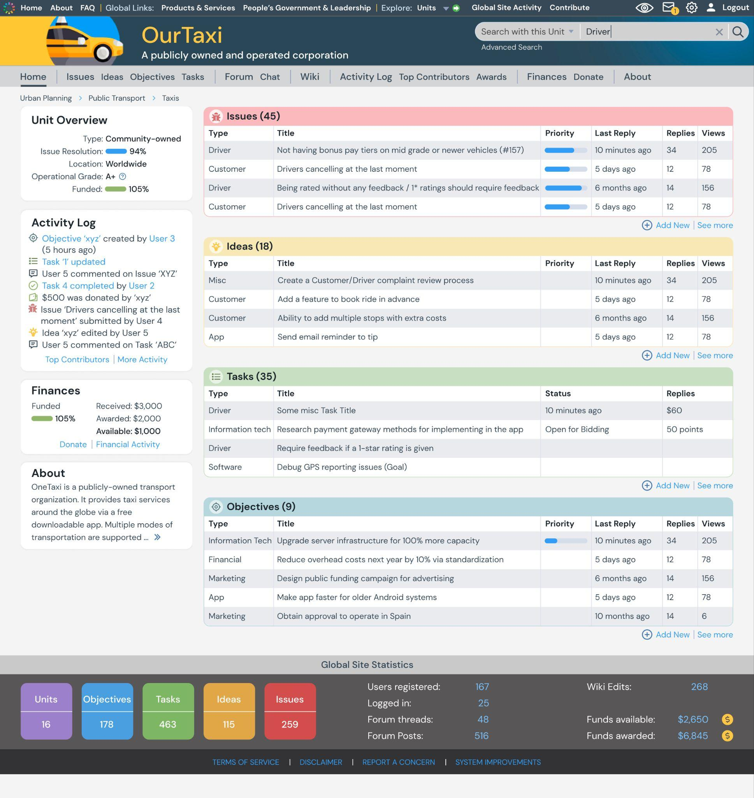

Zoom-in to see details or ask me for a high res version

## Objective View

The view for an objective will match most of the items for the Unit home page for example the Left side, Top and Bottom parts will remain the same. But for the center part, we will show the following items about an objective but also show anything else in the Objectives section. If anything is not clear let me know and we can figure it out together.

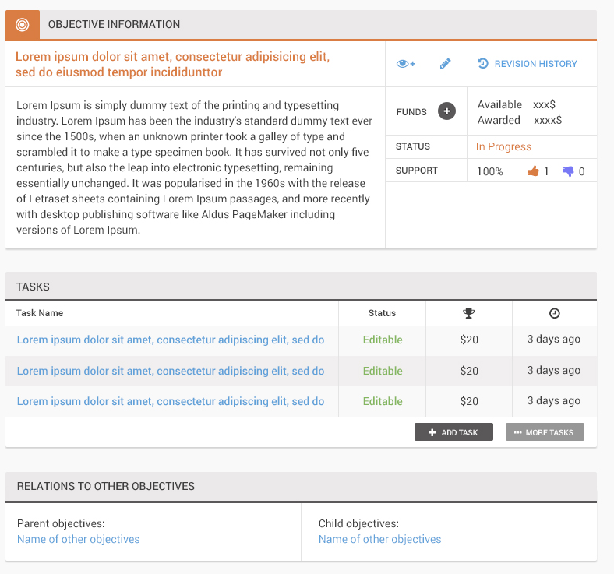

## 

## 

## Task View

Similar to the Objective, here is the central part of a Task View page

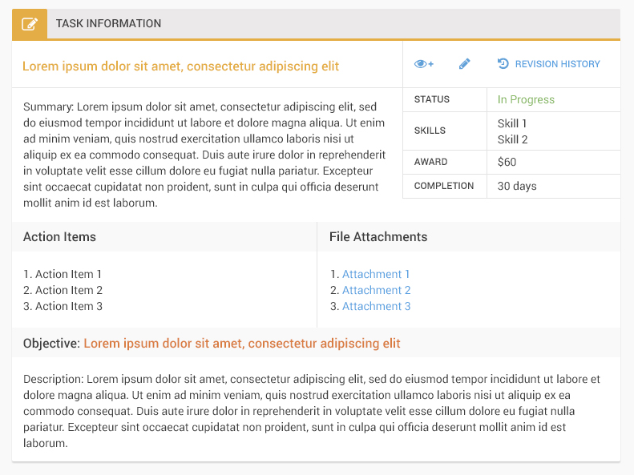

## Issue and Idea View

Similar to other views, we will adopt some parts from the other views. For the center part of an Idea or Issue view, I don't have a design but we can show the relevant items for an Issue or Idea.

## Other Views

We can discuss later what to show for other views.

# Future Tasks

We will try to find a replacement software for the Unit **Forum** and **Chat** (two components). Existing open-source Laravel forum and chat packages may exist and can be investigated to find the best options for us.